**AGRICART: AGRICULTURAL E-COMMERCE PLATFORM**

**Judy Amor Elay**

**Emmanuelle Braindale Gaviola**

**Jelleah Rozette Mapano**

**Anjaenet Maturan**

**Evamae Parinasan**

**Kyle Andrew Pailagao**

**Michaiah El Posadas**

**An Object Oriented Programming Project**

Department of Information Technology

College of Engineering and Technology

University of Science and Technology of Southern Philippines – Claveria Campus

Claveria Misamis Oriental, 9004 Philippines

December 16, 2024

1. **Background of the Study**

Agriculture plays a crucial role in the economy of many countries, serving as the backbone of food production and a source of livelihood for millions. However, traditional agricultural practices often face challenges such as limited market access, inefficient supply chains, and differ prices. These issues hinder farmers from reaching wider markets and maximizing their profits.

By transforming the purchasing and selling of agricultural products, the emergence of digital technology and e-commerce platforms offers a chance to address these issues. By offering an online marketplace for agricultural products here in Claveria Misamis Oriental, an agricultural e-commerce platform, like "Agricart," can help close the gap between farmers and customers. By facilitating good communication between farmers and buyers in Claveria.

This study is motivated by the need to address the pressing issues faced by farmers in accessing markets and achieving economic sustainability. By examining the implementation and impact of Agricart, this research seeks to explore how e-commerce platforms can contribute to the growth and development of the agricultural sector in Claveria.

1. **Objectives**

To develop and assess the effectiveness of Agricart, an agricultural e-commerce platform, in improving market accessibility, operational efficiency, and economic sustainability for farmers and agricultural stakeholders.

1. **To create an online platform** that allows farmers to showcase and sell their agricultural products directly to consumers and businesses.
2. **To analyze the impact of Agricart** on farmers' income by comparing traditional market systems with digital market engagement.
3. **To identify the challenges and opportunities** in implementing an agricultural e-commerce platform in Claveria agricultural contexts.
4. **To enhance market transparency** by providing pricing data and eliminating the need for middlemen.
5. **To promote sustainable agricultural** practices by encouraging the sale of organic and local-sourced products through the platform.
6. **To increase consumer awareness and engagement** by providing detailed product information, reviews, and farmer profiles.
7. **To ensure general** by designing a user-friendly interface accessible to farmers with varying levels of digital literacy.
8. **To evaluate the user-friendliness of the platform**, ensuring that it is accessible and easy to use for farmers with varying levels of technological skills.
9. **To assess how the platform** helps reduce the time and costs involved in finding buyers and suppliers for agricultural products.
10. **To increase the market** visibility of small and medium-scale farmers, helping them connect with potential buyers, wholesalers, and retailers.
11. **Scope and Delimitation of the Study**

### ****Scope****

This study focuses on the development and evaluation of **Agricart**, an agricultural e-commerce platform designedfacilitate direct connections between USTP-Claveria farmers and agriculture students with potential customers.The platform aims to address challenges in traditional agricultural markets, such as limited market access, inefficiencies in the supply chain, and price differ.

1. **Platform Development:** Designing and implementing features such as manage category, manage supplier, manage user, manage product, etc.
2. **Target Users:** Farmers and students in Claveria.
3. **Data Collection:** Gathering data on user satisfaction, income changes among farmers and students, and platform usability through system analytics.
4. **Timeframe:** The study covers a pilot period to assess the platform's functionality and impact on the agricultural supply chain.

### ****Delimitation****

The study on **Agricart: Agricultural E-Commerce Platform** is confined to specific parameters to ensure a focused and manageable scope. These delimitations ensure that the study remains focused on the platform's core objectives while addressing practical challenges within the identified boundaries.

1. **Target Users**: The study primarily involves farmers and students.
2. **Product Inclusion:** The platform supports the listing and sale of fresh agricultural products such as fruits, vegetables, and etc.
3. **Technological Scope:** Agricart is developed for mobile and web-based platforms, focusing on users with internet access. Areas with limited or no internet connectivity are not included in the pilot phase.
4. **Timeframe:** The study covers a limited pilot period to evaluate the platform's functionality, usability, and initial impact on stakeholders. Long-term performance analysis is outside the study's scope.

**IV. Flowchart**

Start

4

4

4

3

Exit

2

2

1

1

NO

YES

**My Account**

**My Delivery**

**My Account**

**Purchase Details**

**Purchase**

1

**Delivery**

**Admin**

**Supplier**

**User**

**Select**

Sign Up

**DashBoard**

**DashBoard**

**DashBoard**

Log in

Exit

4

3

**Add Supplier**

1

**Transaction**

**Select Supplier**

**Manage Product**

**Manage User**

**Manage Supplier**

**Manage Categories**

**Flow:**

1. **Start:** The process begins with the user starting the system.
2. **Log In:** The user is prompted to log in. If they are already logged in, they proceed to Step 3.
3. **Sign Up:** If the user is new, they have the option to sign up.
4. **Select Role:** After logging in or signing up, the user selects their role: Supplier, Admin, or User.
5. **Dashboard:** Depending on the selected role, the user is directed to their respective dashboard.

* **Supplier Dashboard:** Offers options for "My Account," "My Delivery," and potentially other actions related to supplier management.
* **User Dashboard:** Includes "Purchase," "My Account," "My Delivery," and potentially other user-specific actions.
* **Admin Dashboard:** Provides options for "Dashboard," "Purchase Details," and likely other administrative tasks like Manage Product, Manage Supplier, Manage Categories, Select Supplier, Add Supplier, and Transaction.

1. **Role-Specific Actions:** Within their respective dashboards, users can perform various actions:

* **Manage Products:** Add, edit, or delete product information.
* **Manage Suppliers:** Add, edit, or remove suppliers.
* **Manage Categories:** Create, modify, or delete product categories.
* **Select Supplier:** Choose a specific supplier from the list.
* **Add Supplier:** Add new suppliers to the system.
* **Transaction:** Record a new transaction. Modify existing transactions.

1. **End:** The process concludes with the user exiting the system.

**V. Gantt Chart**

|  |
| --- |
| AGRICART: AGRICULTURAL E-COMMERCE PLATFORM |

|  |  |  |  |  |  |
| --- | --- | --- | --- | --- | --- |
| **PROCESS** | AUG | SEPT | OCT | NOV | DEC |
| Planning |  |  |  |  |  |
| Research |  |  |  |  |  |
| Design Process |  |  |  |  |  |
| Development |  |  |  |  |  |
| Database Implementation |  |  |  |  |  |
| Testing |  |  |  |  |  |

* **Planning:** To ensure Agricart's functionality, user acceptance, and scalability, contributing to the digital transformation of the agricultural sector.
* **Research:** Aims to investigate the feasibility, development, and impact of an online marketplace designed to connect farmers with consumers and businesses.
* **Design Process:** Agricart ensures a well-planned and user-centric platform that effectively addresses the challenges in the agricultural marketplace while promoting digital transformation in the sector.
* **Development:** Ensures that Agricart is a robust, scalable, and user-friendly platform that effectively addresses the needs of farmers and students in the agricultural marketplace.
* **Database Implementation:** Ensures efficient data management, secure storage, and seamless retrieval of information essential for platform functionality.
* **Testing:** Operate as intended, with all features performing according to the defined requirements. The goal is to verify the correctness of specific functionalities and provide users with a seamless experience.

**VI. System Design**

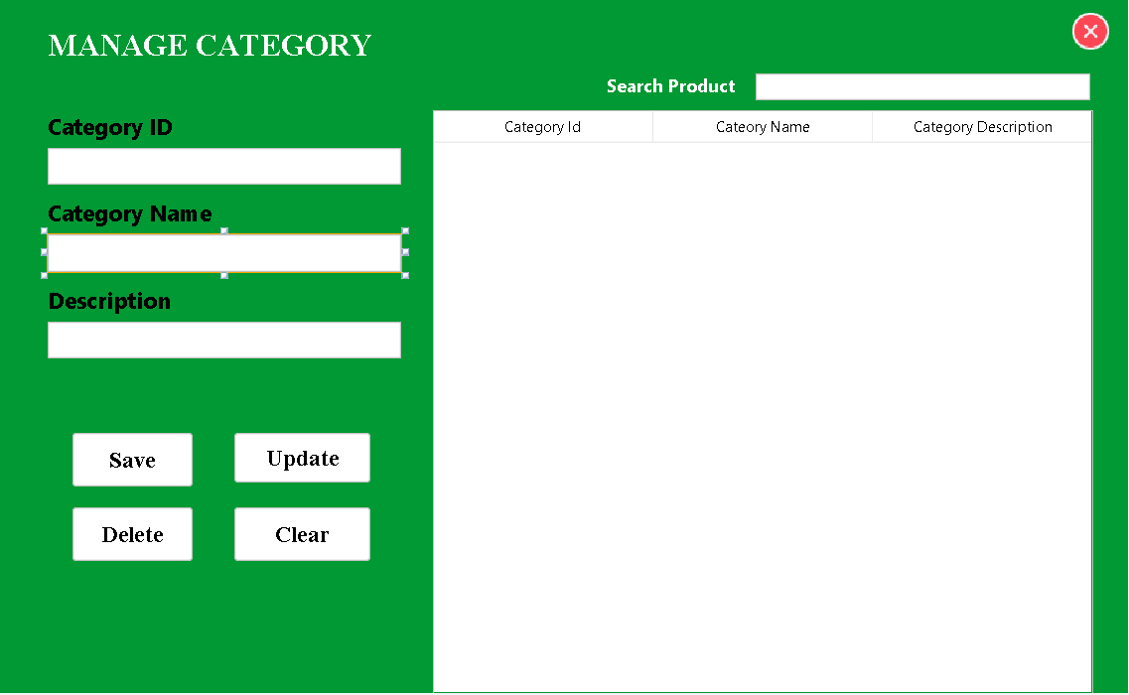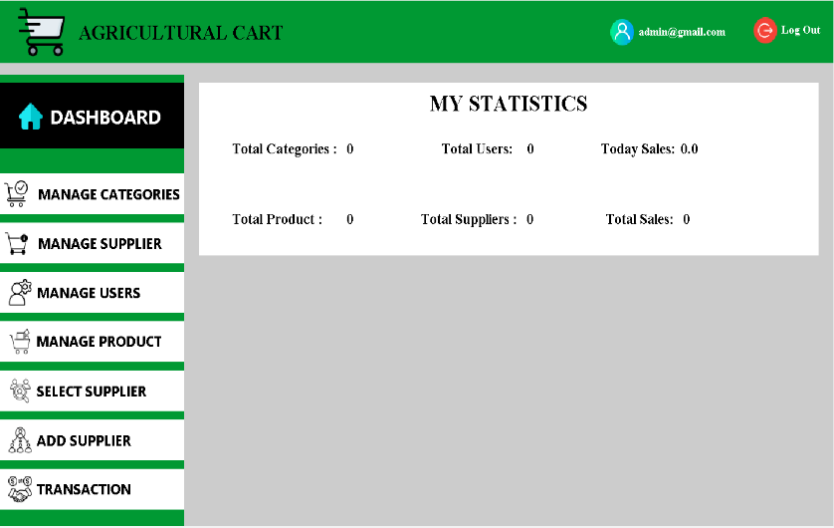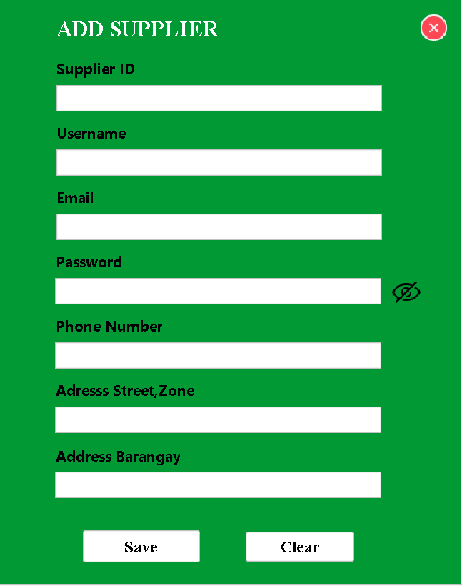

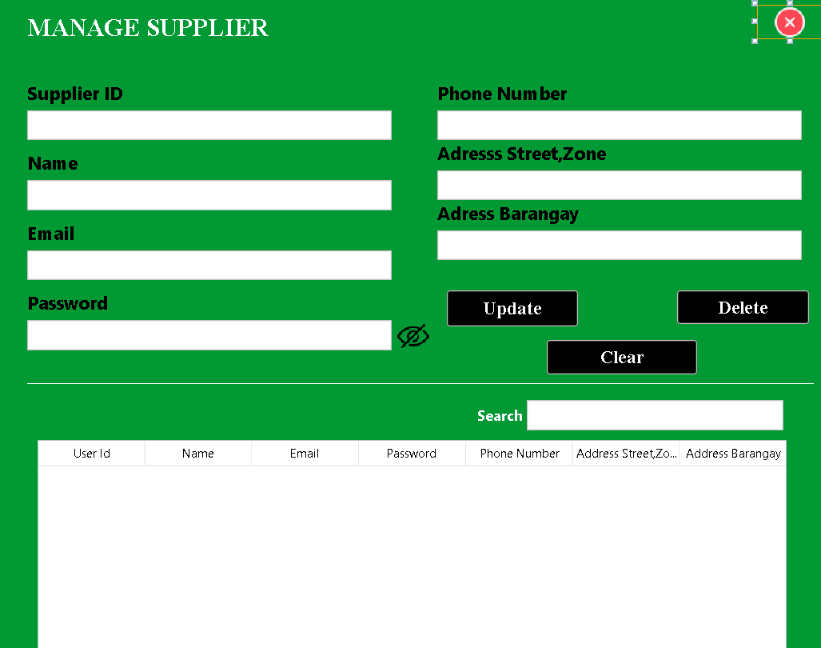

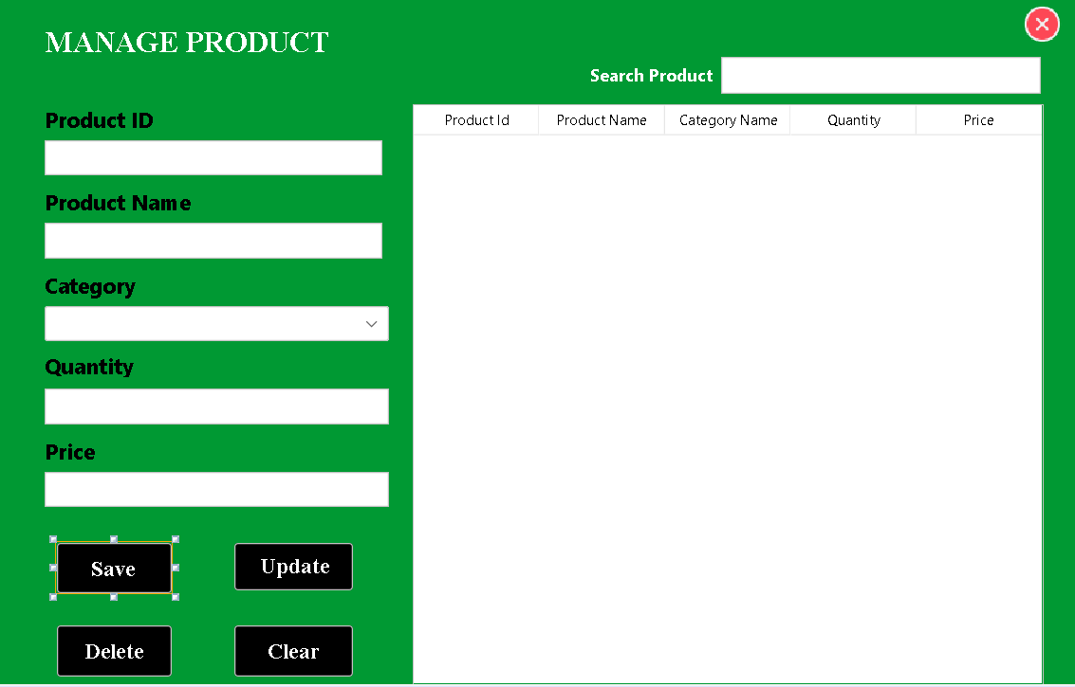

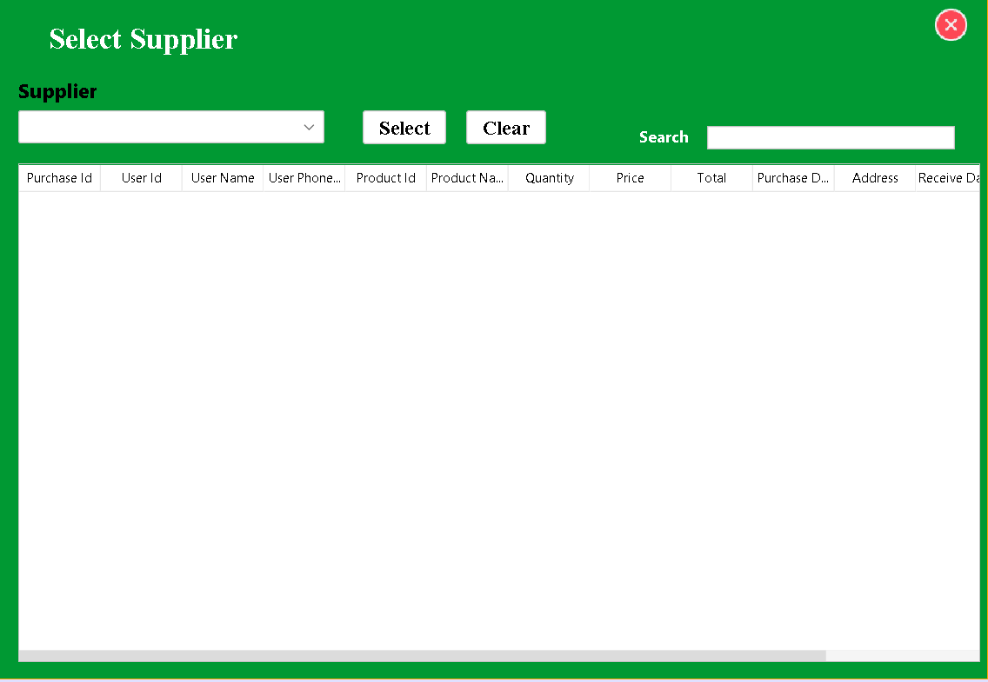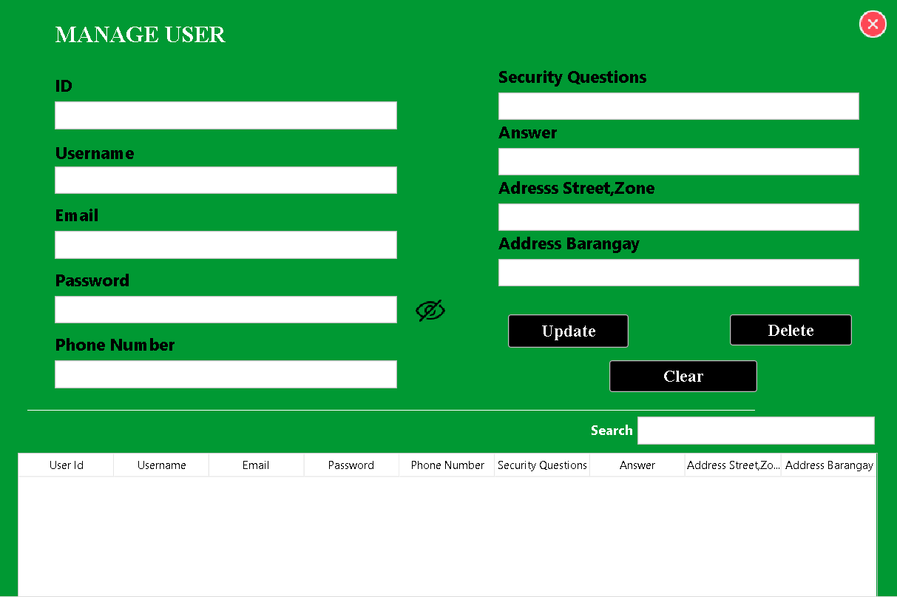

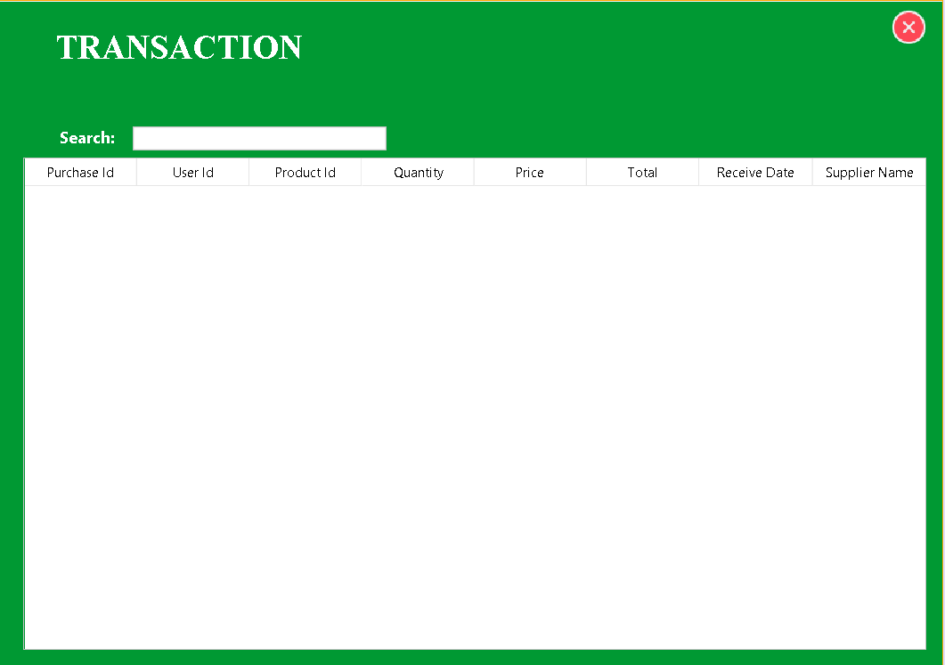

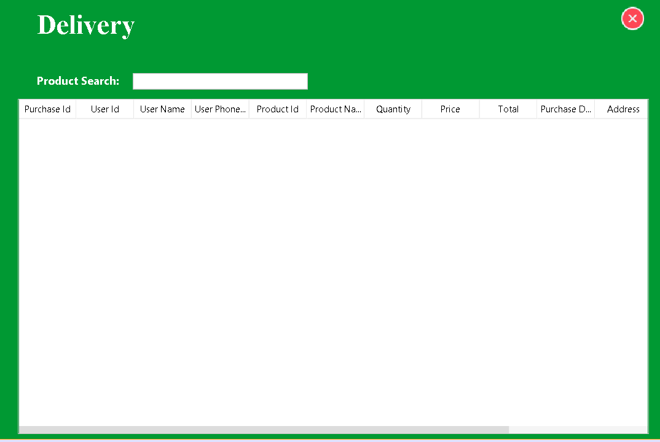

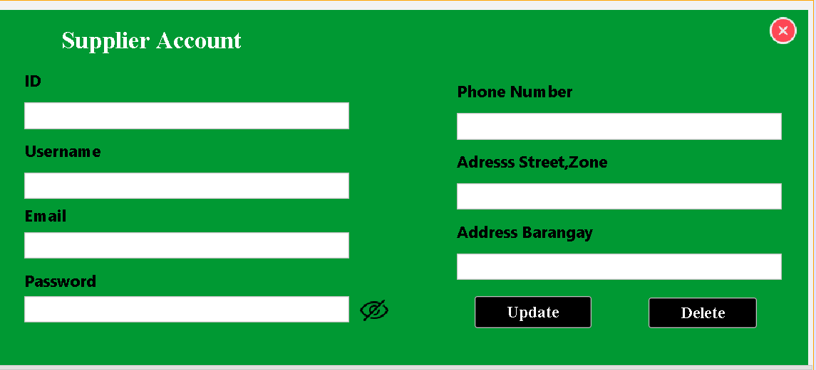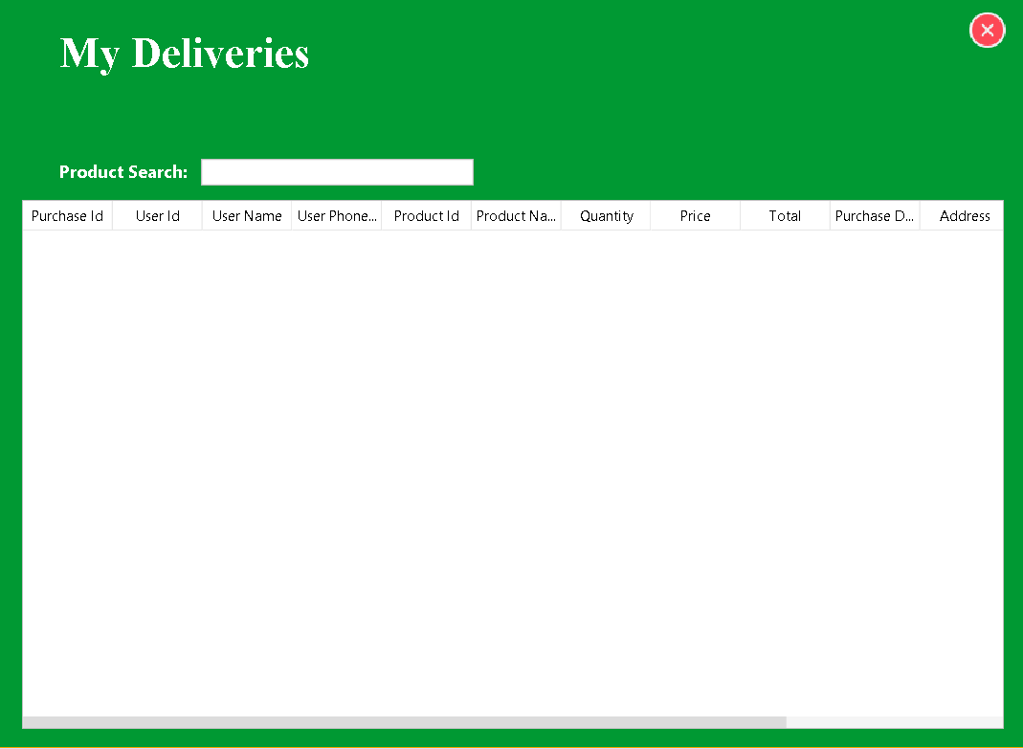

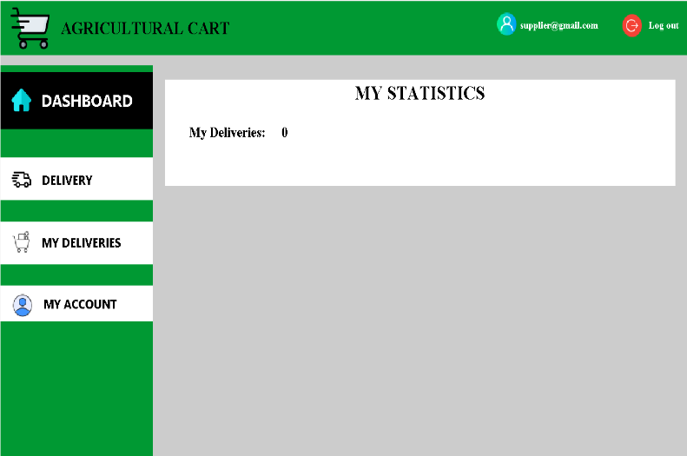

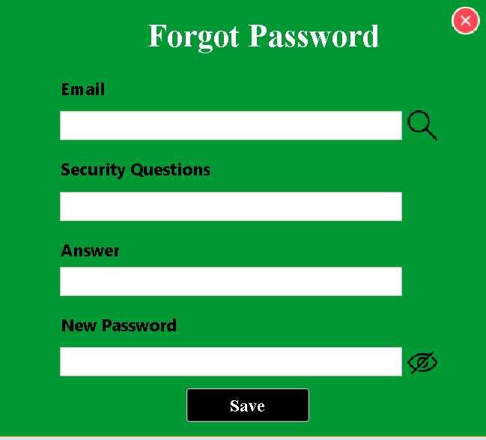

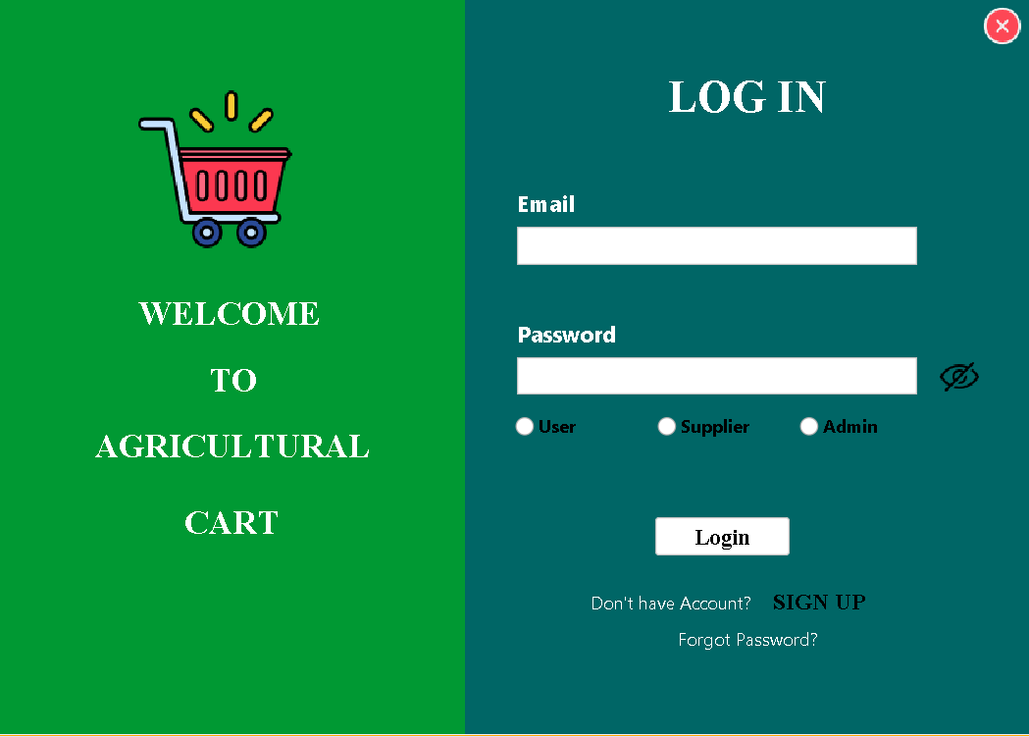

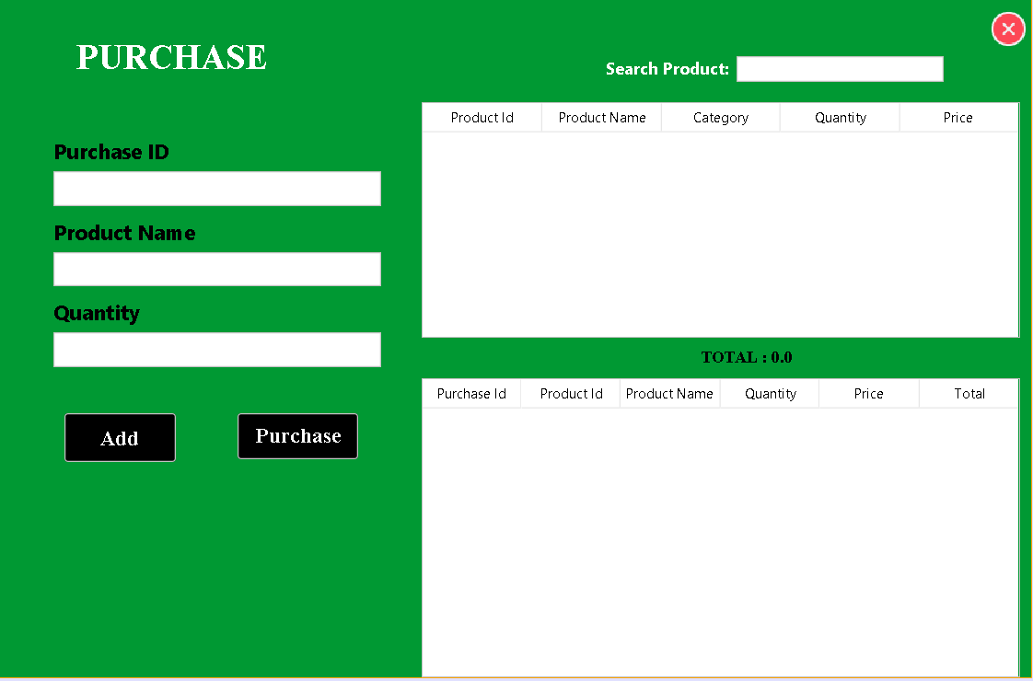

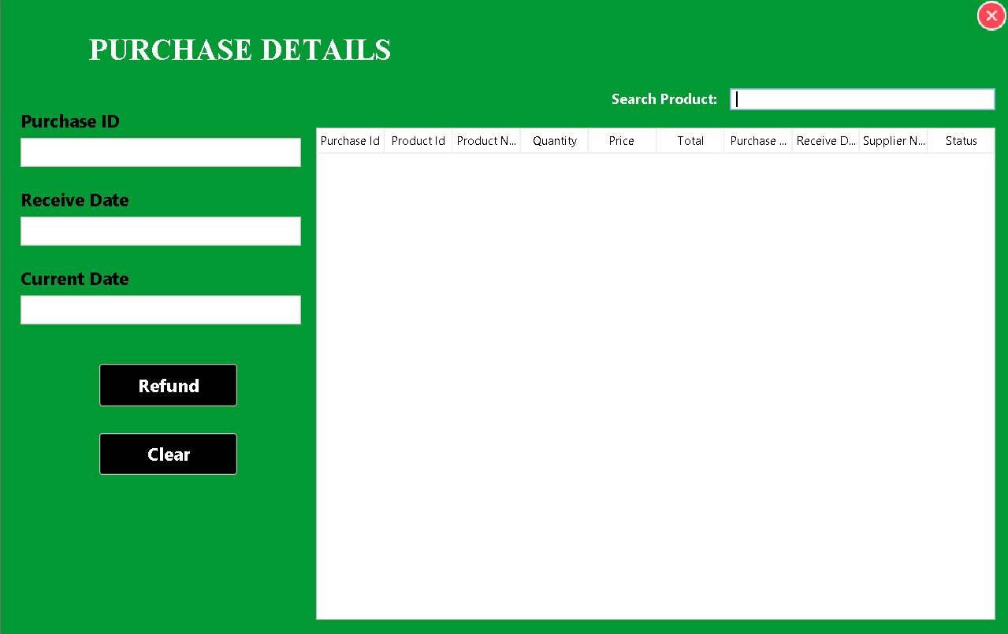

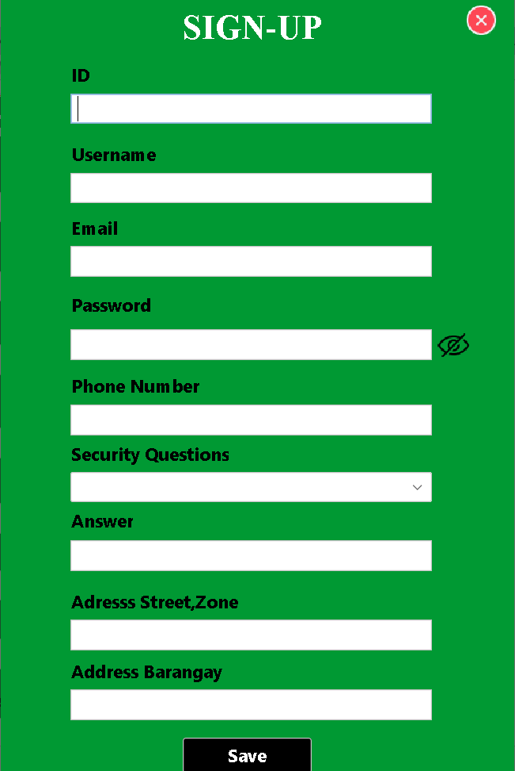

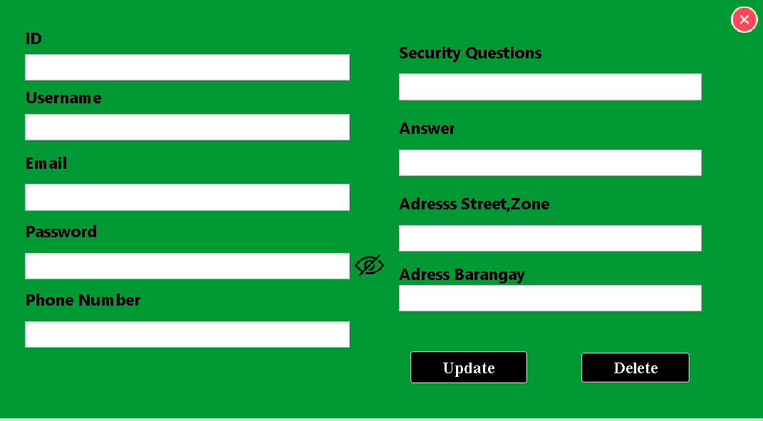

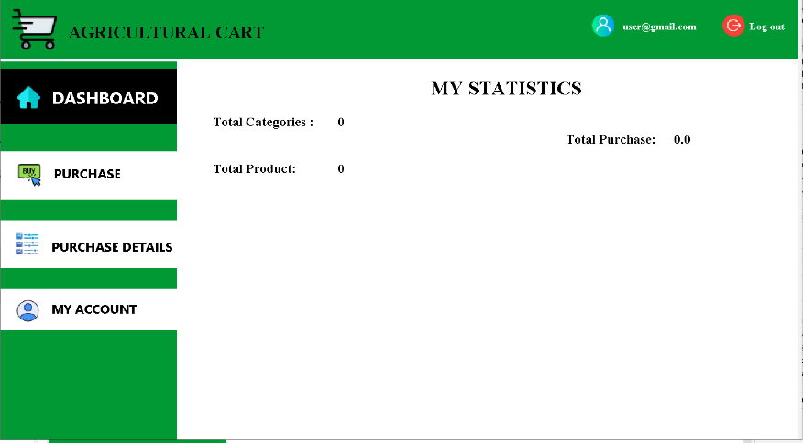

### User Flow:

1. **Login:** Users start by logging into the system using their credentials.
2. **Dashboard:** Upon successful login, users are directed to the dashboard. This provides an overview of key metrics, notifications, and quick access to various system functionalities.
3. **Manage Suppliers:**

* **Add Supplier:** Users can add new suppliers by inputting information such as name, address, contact details, etc.
* **Manage Existing Suppliers:** Users can view, edit, or delete existing supplier records.

1. **Manage Categories:**

* **Add Category:** Users can create new product categories.
* **Manage Existing Categories:** Users can view, edit, or delete existing categories.

1. **Manage Products:**

* **Add Product:** Users can add new products, specifying details like name, description, category, supplier, price, and quantity.
* **Manage Existing Products:** Users can view, edit, or delete existing products.

1. **Transactions:**

* **Add Transaction:** Users can record transactions, such as purchases or sales, including details like date, quantity, price, and supplier.
* **View Transaction History:** Users can review past transactions.

1. **Delivery:**

* **Manage Deliveries:** Users can track and manage deliveries, including scheduling, assigning delivery personnel, and updating delivery status.

1. **My Deliveries:** Users can view their assigned deliveries and their status.
2. **Supplier Account:** Suppliers can access their account to view orders, update information, and communicate with the system.
3. **Forgot Password:** Users can recover their password if forgotten.
4. **Exit:** Users can log out of the system.

**VII. Conclusion**

The development of Agricart aims to address critical challenges in the agricultural sector by providing farmers and students with a reliable, user-friendly e-commerce platform. Through comprehensive planning, design, development, testing, and deployment, Agricart ensures accessibility, efficiency, and scalability.

The challenges faced by the agricultural sector, including limited market access, inefficient supply chains, and differ pricing, underscore the need for innovative solutions. Through the integration of digital technology, platforms like **Agricart** can transform traditional agricultural practices by creating a direct link between farmers and students. This approach not only ensures fair pricing but also empowers farmers to maximize their profits and broaden their market reach.

The findings and insights from this study highlight the transformative potential of e-commerce platforms in addressing longstanding issues in agriculture. By manipulating technology to bridge the gap between producers and consumers, Agricart serves as a model for enhancing economic sustainability and fostering equitable growth in the sector. This research maintains the importance of digital innovation in driving progress and sustainability in agriculture, ultimately contributing to the well-being of farmers and the resilience of food systems.

**VIII. Recommendation**

Implementing these recommendations will significantly enhance the effectiveness of **Agricart**, making it a more inclusive and efficient platform. By addressing the diverse needs of farmers and students, expanding market access, and improving logistics, Agricart can play a pivotal role in transforming the agricultural sector. Furthermore, ensuring platform security, offering user-friendly, and fostering sustainable practices will contribute to long-term growth and sustainability in the agricultural e-commerce space.